HINAMIO Shamisen Live performance
Do you know ‘Shamisen’？
It is Japanese traditional musical instrument born in Osaka.
I play Japanese traditional songs named Min’yo with shamisen.
Min’yo lyrics and melodies there are very deeper meanings. Min'yo evokes the nostalgia of hometowns and their way of life, it also conveys thoughts and hopes of people that sometimes cannot simply be put into words. As such, Min'yo can be seen as more than just songs.
I invite you to experience Min'yo, accompanied by Shamisen that was created in Osaka.
During my performances, I usually explain the lyrics and songs that were played, but due to the recent circumstances(covid 19), this will be a live performance without singing and explanations.

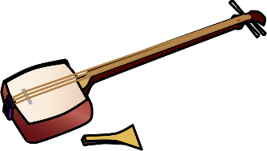
Performer : Hinamio (syamisen)
Length of performance : about 20 minutes
Charge : 1~4person=2500 Japanese yen for all
5person ~ =500 Japanese yen per person
place : public space or your guest house lobby or living room
If you want to listen to HINAMIO live, please ask the staff of your guest house with this flyer.
連絡先：藤本 雛澪HP https://www.hinamio.com/
お問合せページより入力をお願いします。
photo = OK
upload to SNS = NG
recording = NG Thank you!!

